

June 20, 2017 Week #4
The weather as of late is a good reminder that it is, in fact, still spring. We are patiently waiting for some of our new plantings to emerge from the soil, and the odds are that some of them will need to be replanted because it has been so cool and cloudy. The good news is that the corn is over Farmer Henry’s knee, the winter and summer squash are growing well, and we are harvesting the first of the potatoes and peas this week! There is nothing like potatoes fresh from the ground! Farmer Wilbur is starting his first full week at the farm this week. He’s the tall fellow in need of a summer hair cut ☺.

Our U-pick items this week are herbs and Spinach. You are welcome to pick any herbs you would like from the Herb Garden. There will be ties and clippers available on the bench in the Herb Garden or, in case of rain, in the barn. Look for the yellow flag in the field to show you where the spinach is located. It is across from the coop. We will have bags and scissors there. Each membership can pick a full bag.

For those of you who are paying in installments—the June payment is due. I will have the Square reader in the barn if you would like to pay with a debit or credit card, otherwise feel free to bring in a check. The amount due is as follows:
Small share $80.00
Partial share $100.00
Full share $150.00

Prairie Bottom Farm is a non-smoking farm. All animals must be kept in your car (service animals are the exception). Please watch your step, the ground can be uneven. Vehicles are driving in and out, especially on CSA pick up day—please keep your kids close and please keep an eye out for people and chickens.

We are very excited to share this year’s produce with you and look forward to seeing you on Tuesdays between 1:00pm and 6:00pm. If you will not be able to pick up by 6pm please let us know. We can bag up your share and place it in the cold storage room for a later pick-up. We close the barn promptly at 6pm and we are off on Wednesday so we can make arrangements with you to pick up at a later time. If we have not heard back from you by 8am on Friday we will share your produce with the farm chickens.

Please be sure to sign in when you pick up. This will save us confusion at the end of the day and save you a phone call or email verifying that you were here. This season we will have a separate sign up black boards at each share size. We will also have the items color-coded to make your pick-up as easy as possible. Simply find the color that corresponds with your share size: Full Shares are yellow, Partial Shares are orange, and Small Shares are blue.

We will have some recycled plastic and paper bags for your use during CSA pick-up. Feel free to bring your own basket, box, cooler, etc. to pick up your veggies.

Compost Container: If you do not have access to composting we will gladly take any veggie and fruit scraps off your hands. Please place any compost materials in one of the green bags we provide (they will be in a basket by the cash box in the barn) and place the tied bag into the bin outside of the barn. Feel free to include coffee grounds and fruit and vegetable scraps. Please do not include labels, ties, bags, meat products or citrus fruits.

Eggs: Fresh eggs should always be cracked into a small bowl first, in the unlikely event that there is a bad egg. Eggs are available on a first come, first serve basis and are located in the cooler in the main room. Our chickens are fed organic feed and free range. The eggs are $5.00 per dozen.

Jennybean Coffee: if you are interested in purchasing locally roasted organic coffee that will be delivered for pick up with your CSA share you can order from www.jennybeancoffee.com. Go to the “Offerings” tab and fill out the order form on the bottom. Be sure to include Prairie Bottom Drop in the ordering instructions on the order form. Payment will be collected when the coffee is picked up, paid by cash or check. There will be an Honor Box for JennyBean payments. Please place your order by Thursday evening for the Tuesday delivery.
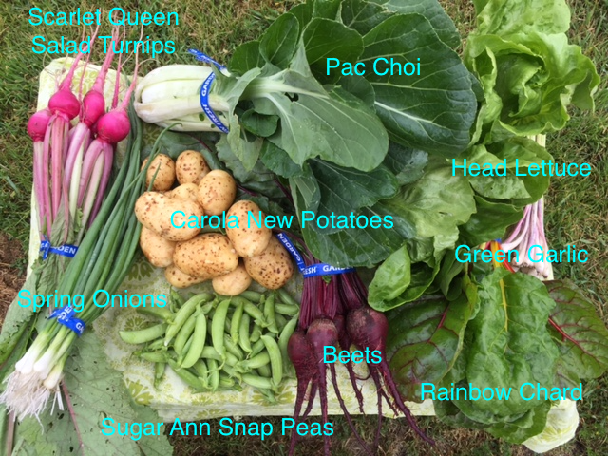
How to store and use:
We rinse all produce after picking and before we package. We recommend that you wash it before you cook with it or eat it. Root vegetables may require a little extra time to soak.
* **Scarlet Queen Salad Turnips—remove bunching tie and separate greens from roots (both are edible) and store in the crisper. Perfect for salads. Roots are delicious roasted, greens are wonderful sautéed.
* **Mixed Spring Onions— remove bunching tie and store in the crisper. A mix of several onions in their tender, young stage. Great in salads or as a topping.
* **Carola New Potatoes— —store in the crisper. These little beauties are perfect steamed…or boiled…or roasted…just perfectly perfect ☺.
* **Sugar Ann Snap Peas— —store in the crisper. Edible pods make these great to snack on.
**Pac Choi—store in crisper. Wonderful in a stir-fry with the spring onions!
** Red Ace Beets — remove bunching tie and store in the crisper. Remove greens form roots (both are edible).
Head Lettuce—store in the crisper. A mix of many varieties. We won’t be picking them until Tuesday morning so I won’t list them here. Wonderful heads for salad, to add to sandwiches, or to use for wraps.
Chard— remove bunching tie and store in the crisper. Chop stems and tear greens for a lovely sauté.
Green Garlic—remove bunching tie and store in the crisper.
**indicates item is found in partial share boxes
*indicates items found in small share boxes
all items are included in the full share boxes

Braised Salad Turnips
1-bunch salad turnips, cleaned and cut into 1-inch thick wedges, and greens chopped
1-tablespoon butter
salt
splash of white wine vinegar
Melt butter in a heavy saucepan. Add turnips and cook until nicely browned on all sides.
Stir in greens and let wilt for a minute or two.
Add a dash or salt and a splash of vinegar.

Sautéed Greens
1-tablespoon olive oil
1 shallot, chopped
1 clove garlic, chopped
1-teaspoon red pepper flakes
2-3 bunches greens, washed, stemmed, and chopped (turnip, beet, chard, kale, collards, spinach)
Freshly ground black pepper
2 tablespoons Dijon mustard
1-cup chicken stock
1/2 cup chopped pecans, toasted
Heat olive oil in Dutch oven over medium heat. Add shallot, garlic and red pepper flakes and sauté until tender and fragrant. Add the washed and cleaned turnip greens. Mix together. Cook until they have wilted down, about 3 minutes. Add pepper to taste. In a small bowl, whisk the Dijon mustard with the chicken stock. Add to the wilted greens and cook until the liquid has all but evaporated. Add the toasted pecans and serve immediately.
Roasted New Potatoes
1 1/2pounds small red new potatoes, halved
3 Tablespoons olive oil
1/2 teaspoon Salt and freshly ground black pepper
Adjust oven rack to lowest position and heat oven to 450 degrees. Toss potatoes with oil, salt and pepper. Arrange, cut side down, on a large lipped cookie sheet or jellyroll pan.
Roast until tender and golden brown, about 30 minutes (check after 20 minutes). Transfer to a serving dish.

Sautéed Snap Peas
1-pound fresh sugar snap peas
1-tablespoon good olive oil
1 1/2 teaspoons kosher salt
3/4 teaspoon freshly ground black pepper
Sea salt or fleur de sel, for serving
Remove and discard the stem end and string from each sugar snap pod.
Heat the olive oil in a large sauté pan over medium-high heat. Add the sugar snap peas, salt and pepper and sauté, tossing occasionally for 3 to 5 minutes, until the sugar snap peas are crisp tender.
Place the sugar snap peas in a serving bowl, sprinkle with sea salt and serve.

On the Horizon in the next few weeks: Arugula, Shelling Peas, and Salad Mix!

